ODD OR EVEN USING SIM8085

**Aim:**

To write an 8085 microprocessor program to check whether a given 8-bit number is odd or even.

**Apparatus Required:**

Laptop with an internet connection

**Algorithm:**

1. Load the number from a specified memory location into register A.

2. Perform an AND operation with 01H to check the least significant bit (LSB).

3. If the result is 0, the number is even; otherwise, it is odd.

4. Store the result in a specific memory location (odd or even flag).

**Program:**

IN 00H

ANI 01H

JZ EVEN

MVI A,01H

OUT 01H

HLT

EVEN: MVI A,00H

OUT 01H

HLT

**Output:**

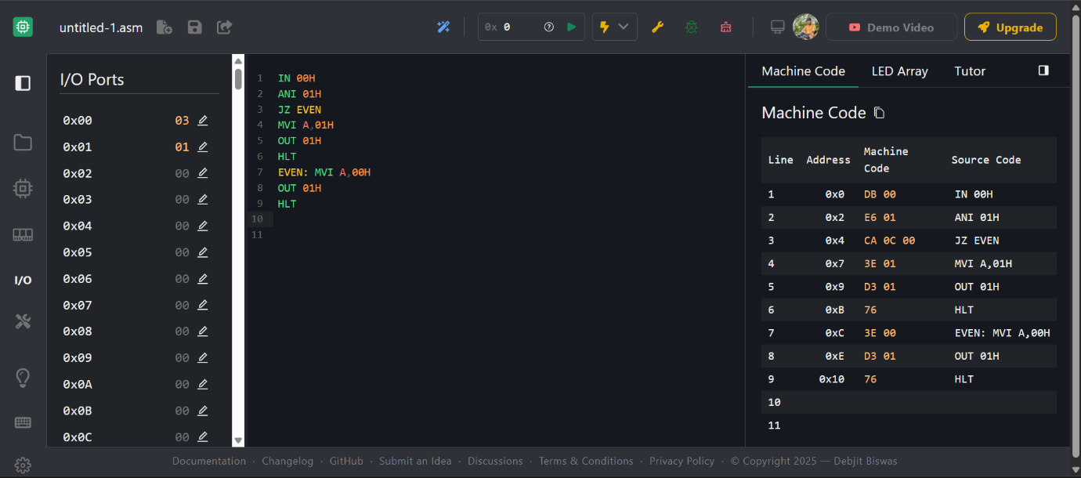

**Input Ports (numbers are read from these ports):** 00H → Input number

**Output Port (result is displayed on this port):** 01H → Result

00H = Even

01H = Odd

**Result:**

The 8085 microprocessor successfully checks whether a given number is odd or even and stores the result in memory.